**DAILY ONLINE ACTIVITIES SUMMARY**

|  |  |  |  |  |  |  |  |
| --- | --- | --- | --- | --- | --- | --- | --- |
| **Date:** | 13-06-2020 | | | | **Name:** | Gudugunti Anirudh | |
| **Sem & Sec** | IV - A | | | | **USN:** | 4AL18CS023 | |
| **Online Test Summary** | | | | | | | |
| **Subject** | | Data communication | | | | | |
| **Max. Marks** | | 30 | | **Score** | | 29 | |
| **Certification Course Summary** | | | | | | | |
| **Course** | Data structures and algorithms in c++ | | | | | | |
| **Certificate Provider** | | | Udemy | **Duration** | | | **2.5hr** |
| **Coding Challenges** | | | | | | | |
| **Problem Statement:** 1: Program to print prime numbers in an interval | | | | | | | |
| **Status:** Completed | | | | | | | |
| **Uploaded the report in Github** | | | | yes | | | |
| **If yes Repository name** | | | | https://github.com/alvas-education-foundation/anirudh_gudugunti/tree/master/daily_progress | | | |
| **Uploaded the report in slack** | | | | yes | | | |

**Online Test Details:** It was from modules 1 and 2 and the test was for 30 minutes having 30 questions, all multiple choice questions. The questions were simple and optimal and the score that I got was 29/30.

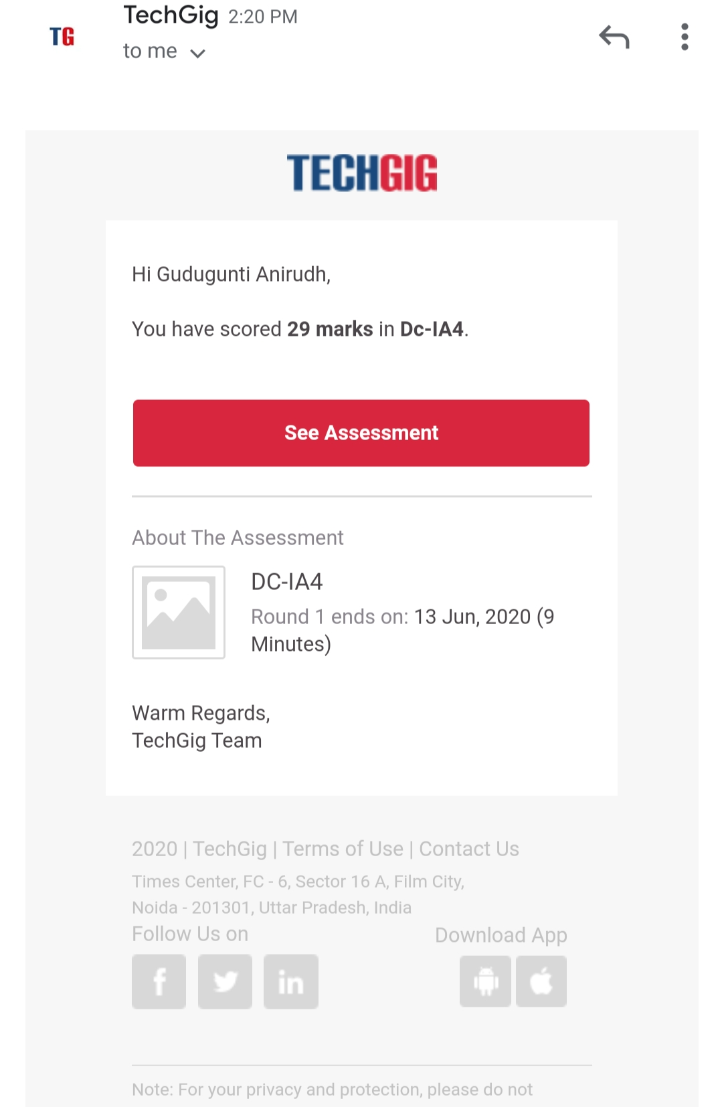

Snapshot of certification course:

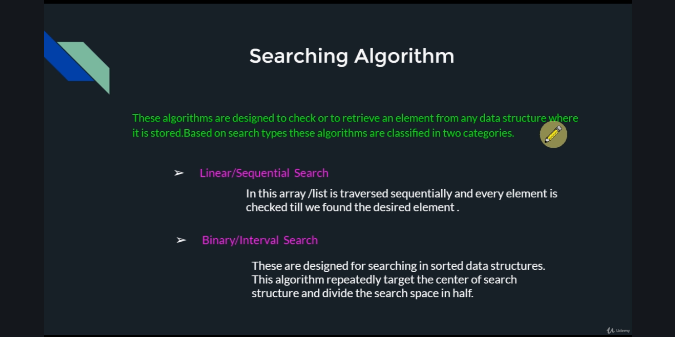1. Introduction to searching algorithms in data structures.

2. Introduction to linear search and binary search.

**Online coding:**

Problem 1: (using Python) Program to print prime numbers in an interval.

